**Software Requirements Specifications (SRS)**

**Project: Poker Game for Window phone 7**

*Version 1.0*

Document History

|  |  |  |  |  |  |
| --- | --- | --- | --- | --- | --- |
| Version | Date | Author | Description | Approved By | Approved on |
| 1.0 | 08-June-2011 | Tarun Pahuja |  |  |  |
|  |  |  |  |  |  |

*1.* Introduction 4

*2.* BUSINESS REQUIREMENTS 4

*3.* Scope 5

*4.* Client Background 8

*5.* Stakeholders 8

6 Assumptions, Suggestions, Queries, Note 9

6.1 Assumptions 9

6.2 Suggestions 9

7 Requirements description 9

8 Application Overview 14

8.1 ARCHITECTURE Goals and Constraints 14

9 High Level Application Design 14

10 Non Functional Requirements 15

11 Use Case Summary 15

12 Reliability 15

13 Security 15

14 Recoverability 15

15 Maintainability 15

16 Extensibility 15

# Introduction

Poker is a family of [card games](http://en.wikipedia.org/wiki/Card_game) that share [betting](http://en.wikipedia.org/wiki/Betting_%28poker%29) rules and usually (but not always) [hand rankings](http://en.wikipedia.org/wiki/List_of_poker_hands). Poker games differ in how the cards are dealt, how hands may be formed, whether the high or low hand wins the pot in a showdown (in some games, the pot is split between the high and low hands), limits on bet sizes, and how many rounds of betting are allowed.

In most modern poker games, the first round of betting begins with some form of forced bet by one of the players. In standard poker, each player is betting that the hand he has will be the highest ranked. The action then proceeds clockwise around the table and each player in turn must either match the maximum previous bet or [fold](http://en.wikipedia.org/wiki/Betting_%28poker%29#Fold), losing the amount bet so far and all further interest in the hand. A player who matches a bet may also "raise", or increase the bet. The betting round ends when all players have either matched the last bet or have folded. If all but one player fold on any round, then the remaining player collects the [pot](http://en.wikipedia.org/wiki/Pot_%28poker%29) and may choose to show or conceal their hand. If more than one player remains in contention after the final betting round, the hands are revealed and the player with the winning hand takes the pot. With the exception of initial forced bets, money is only placed into the pot voluntarily by a player who, at least in theory, rationally believes the bet has positive [expected value](http://en.wikipedia.org/wiki/Expected_value). Thus, while the outcome of any particular hand significantly involves chance, the long-run expectations of the players are determined by their actions chosen based on [probability](http://en.wikipedia.org/wiki/Probability), [psychology](http://en.wikipedia.org/wiki/Psychology) and [game theory](http://en.wikipedia.org/wiki/Game_theory).

# BUSINESS REQUIREMENTS

* Game must have ability to play with player around the world on windows phone
* Game must have ability to have 8 players on a table.
* Game must have ability to play game with minimum two players.
* Game must have ability to have different denomination of tables. For e.g., $5 minimum bet, $200 minimum bet, etc.
* Game must have ability to create a profile and upload a photo with the profile.
* Game must have ability to play without a profile.
* Game must have ability to accumulate chips as long as the player logs in from the same device.
* Brief tutorial on the game.
* Start the game with $50000.
* Give money in $5000 increments in case of zero balance after initial $50k. Player should be able to request money.

# Scope

**In Scope:**

* **Localization:** This application will support only English language.
* **Splash Screen:** A video/moving image splash screen will be shown while the game is loaded before showing the menu screen to the user.
* **Game Algorithms:**

The game algorithms will contain all of the following:

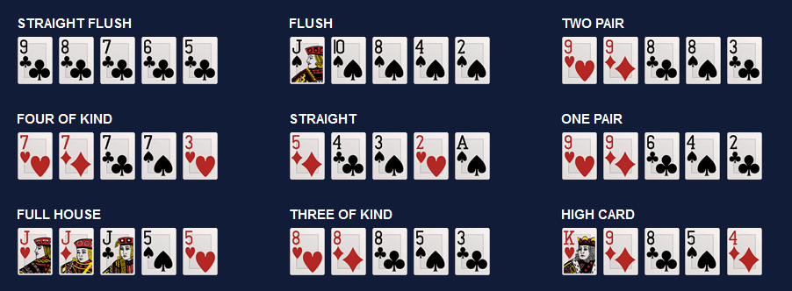

1. **STRAIGHT FLUSH:**

A straight flush (five consecutive cards all of the same suit) beats four of a kind. Aces can be high or low. An ace-high straight flush is called a royal flush, the best possible hand in poker.

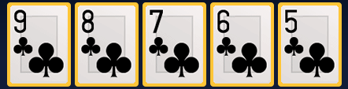

1. **FLUSH:**

A flush beats a straight. A flush is any five cards all of the same suit (i.e., all diamonds or all spades, etc.). If two of more players share a flush then the player with the highest card (all the way to the fifth card if necessary) in the flush wins.

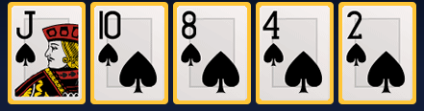

1. **TWO PAIR:**

Two pair beats a pair. If two or more players have two pair, then the highest pair determines the winner. For example, a pair of aces and sevens beats a pair of kings and queens. If two or more players have the same two pair then the fifth card kicker determines the winner.

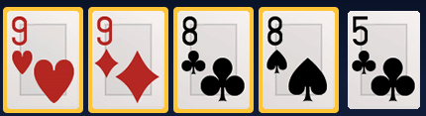

1. **FOUR OF KIND:**

Four of a kind (four cards of the same rank) beats a full house. If two or more players share the same four of a kind, then the fifth card kicker determines the winner.

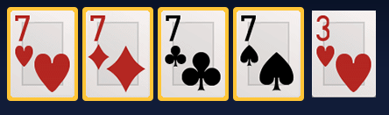

1. **STRAIGHT:**

A straight beats three of a kind. A straight is five consecutive card ranks. Aces can be high or low so the lowest straight is ace through five while the highest is ten through ace. There are no kickers with straights since all five cards are needed to make the hand.

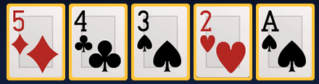

1. **ONE PAIR:**

A pair (two cards of the same rank) beats high card. The highest pair is a pair of aces. If two or more players have the same pair, then the highest of the three remaining cards (known as kickers) determine the winner.

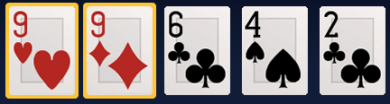

1. **FULL HOUSE:**

A full house beats a flush. A full house is the combination of three of a kind and a pair. If two or more players have a full house then the player with the best three of a kind wins. If those are the same then the player with the best pair wins.

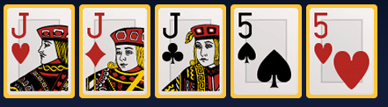

1. **THREE OF KIND:**

Three of a kind (three cards of the same rank) beats two pair. Three aces is the best of these. If two or more players share the same three of a kind hand, the two remaining kickers determine the winner.

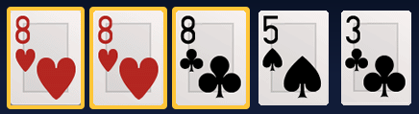

1. **HIGH CARD:**

Cards are ranked deuce (2) as the lowest to ace as the highest. If two or more players have the same high card, then the second highest card (and so on, to the fifth card if necessary) determine the winner.

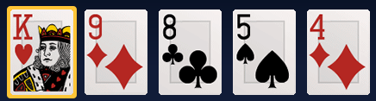

**Out of Scope:**

* Any feature which is not mention above will be out of scope from this project.

# Client Background

….

# Stakeholders

| **Stakeholder** | **Interests, Expectations, Concerns** |
| --- | --- |
| Project Sponsor (Summet) | To receive a high quality product, that meets their expectations. |
| Tarun Pahuja | To develop a product exceeding sponsor’s expectations. |
| Bobby | Bridge between the Sumeet and the Tarun. |
| Developer | (Tarun Pahuja) Provides inputs, and builds the product deliverable(s). |

# Assumptions, Suggestions, Note

# Assumptions

1. Summet will help Tarun in providing images required for the gaming screens.

# Suggestions

1. The game should be playable in both connected and disconnected modes. If a user is having no access to internet, he should be able to play against computer (i.e. a set of 7 players).
2. Reports should be there where in a user can select last played three games.
   1. **NOTE:**

NA

# Requirements description

Please find below requirement description for each section with images. This section contains the screenshots(which may differ from the actual) for this game.

1. **Splash Screen**

This will contain the company Logo image for which this game is being created. Kindly refer to the below screenshot:

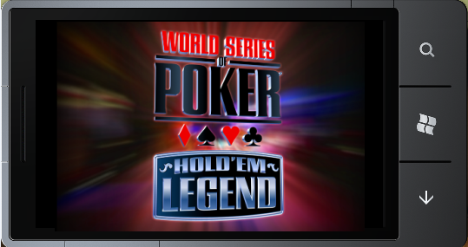

1. **Front Page**

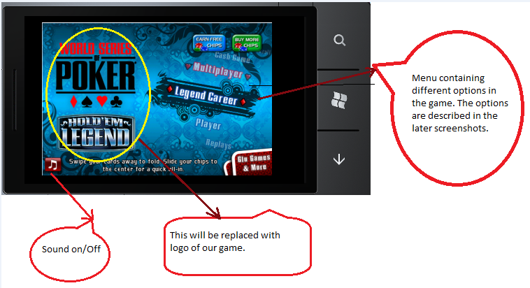

1. **User Profile :**

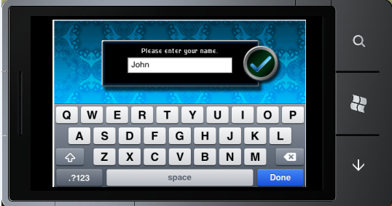

After selecting the game play from the menu, user will be prompted for creating a user profile that will be saved locally. Here only name is shown, but we will provide an interface where a user can select the image from the image gallery of the phone.

1. **Legend Career( for game play in Menu)**

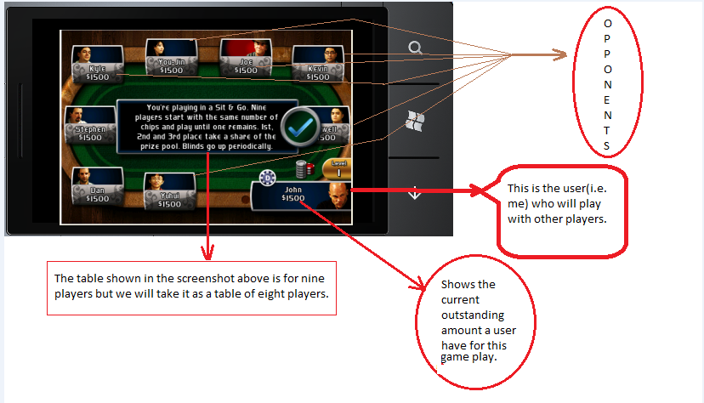

User will be shown with **how to proceed (help)** while playing the game. Refer to the below screenshot for next step:

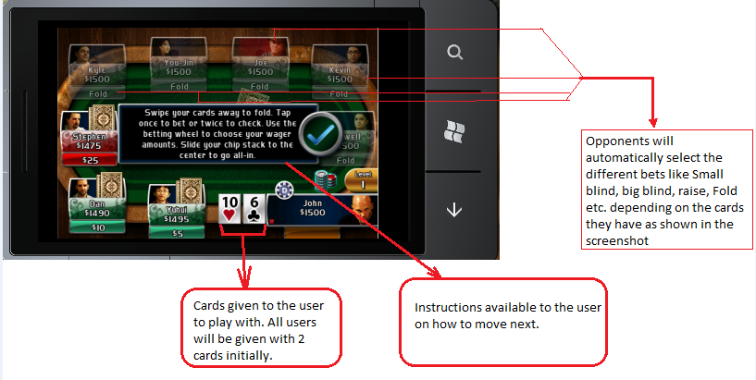

User can select the money by clicking on the chips near to his name. Refer to the below screenshot:

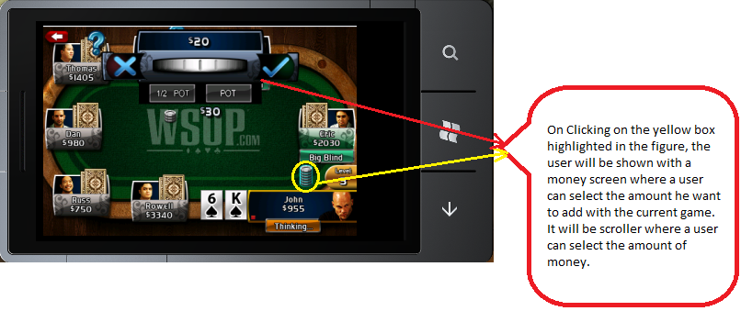

1. **Different GamePlays:** User will be given with an option to select different gameplays in the game. He can select any of the provided options. Refer to the below screenshot for this:

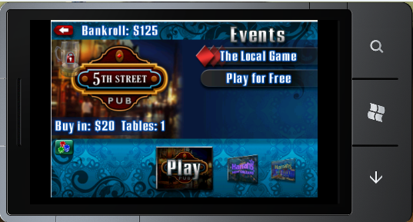

# Application Overview

This application will communicate with web service which will further communicate with database on server when the player is playing online.

## 8.1 ARCHITECTURE Goals and Constraints

Web service should be able to provide data very fast and smoothly. It should have implemented caching in it. Web service should be developed for handling mobile application request which need data very fast. If there are more data exist in database then web service should care about pagination and return page wise data, So that mobile application can handle that data easily.

# High Level Application Design

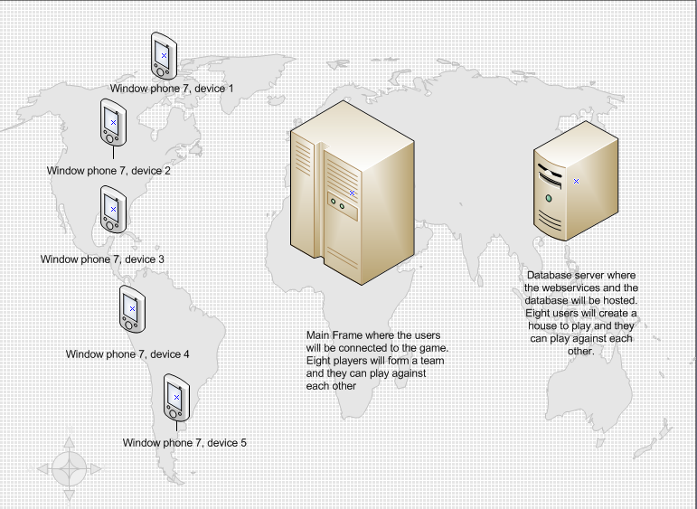

Above figure shows the communication process between different window phone 7 devices, server and the main frame.

# Non Functional Requirements

**Software:** Microsoft Visual Studio 2010, C#.net, Windows phone 7 developer tools, Windows 7

**Hardware:** Windows Phone 7 device.

# Use Case Summary

NA

# Reliability

Application will be more reliable as Windows phone 7 is more reliable device. It will never lose connections. Application will check the user connectivity while communicating with API and if it found any connection loss it will notify to user.

# Security

For making application communication secure we should send secure web service messages, So that all messages will go with a header which will keep user credentials i.e. soap header and soap envelop.

# Recoverability

We are using subversion and Visual source safe tools, so it’s very easy to recover the code if it lost anyhow. We maintain the proper code versioning and labeling of code on each release.

# Maintainability

The application code will be well commented and documented so that it will be easy to maintain the code in future for next version release.

# Extensibility

The application code and architecture will be designed in such a way, so that it will be very easy to extend the existing functionality or add new functionality in existing code.